PHP Exercise 3

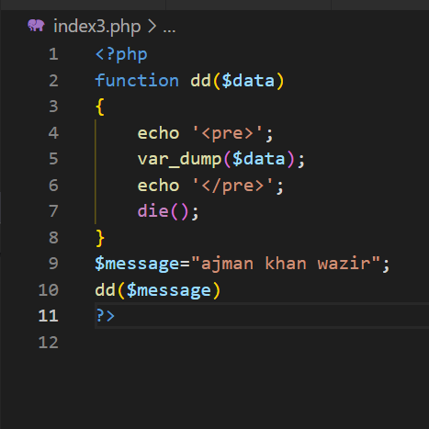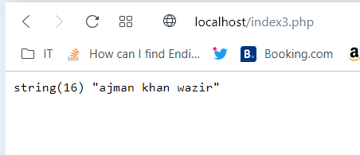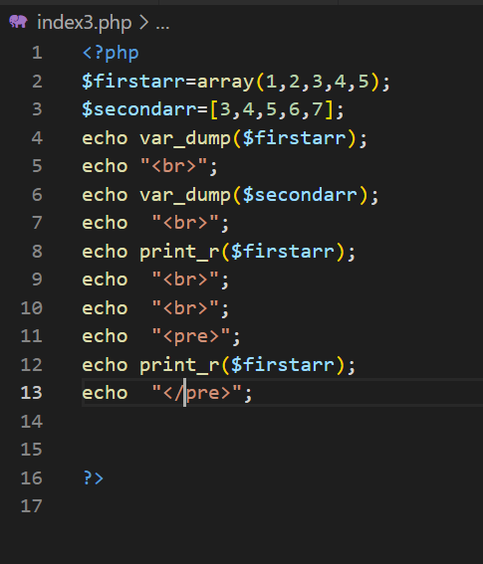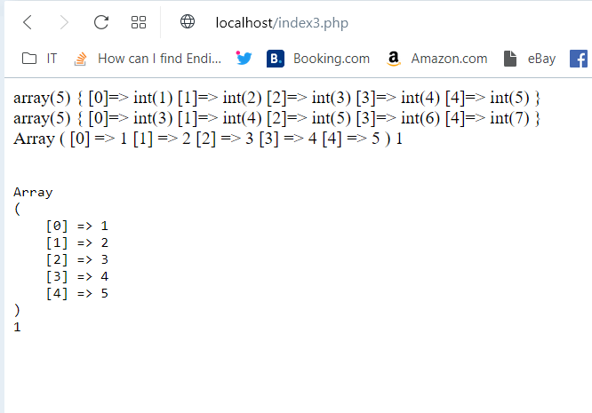

**Array examples :**

<?php

function print_array($data)

{

    echo  "<pre>";

echo print_r($data);

echo  "</pre>";

}

$scores=[45,67,89,78];

$scores[]=99;

$scores[5]=102;// add an elements

$scores[5]=103;// to change an existing elements

print_array($scores);

?>

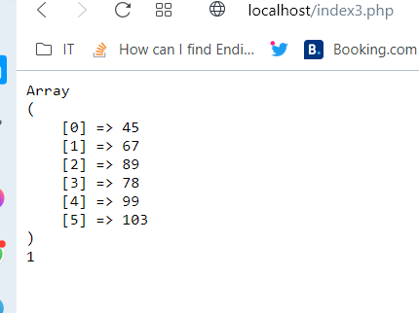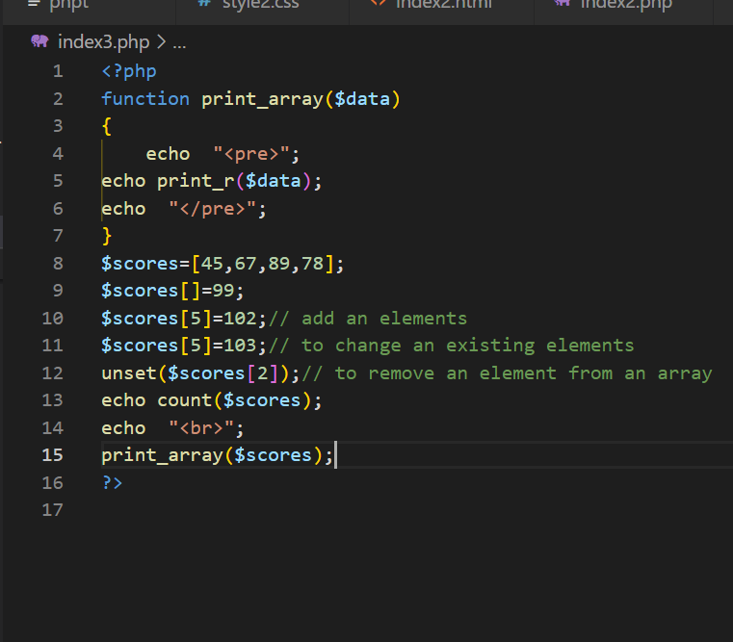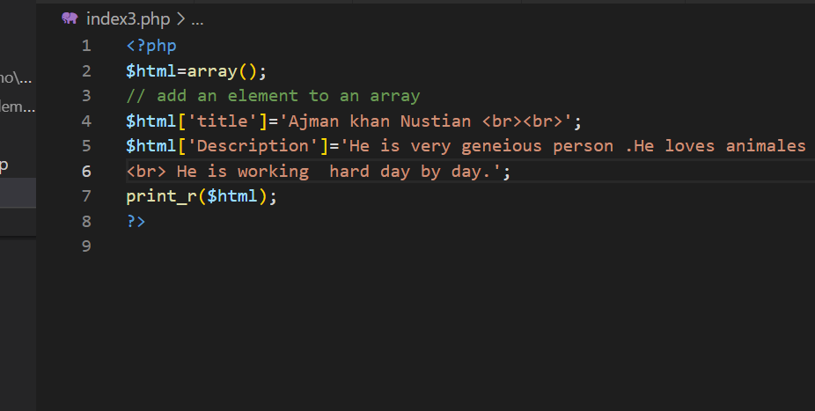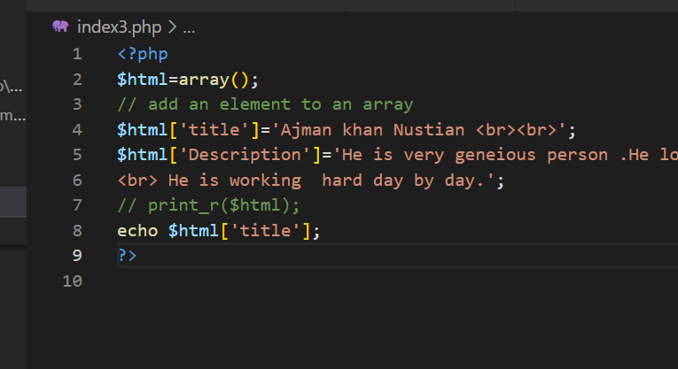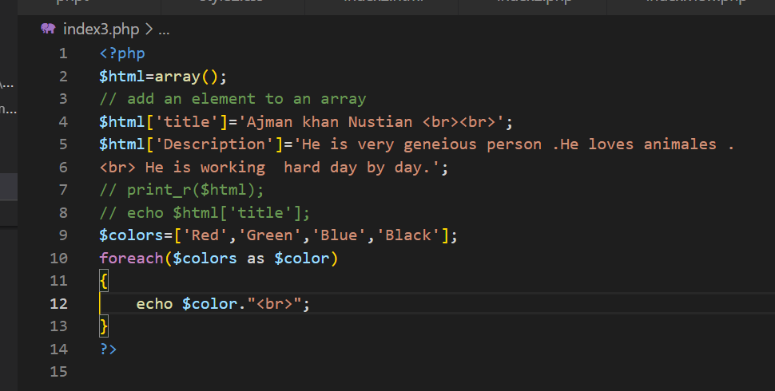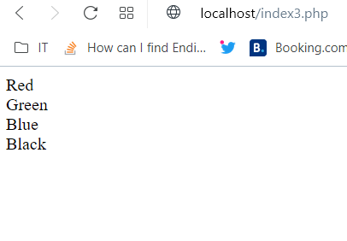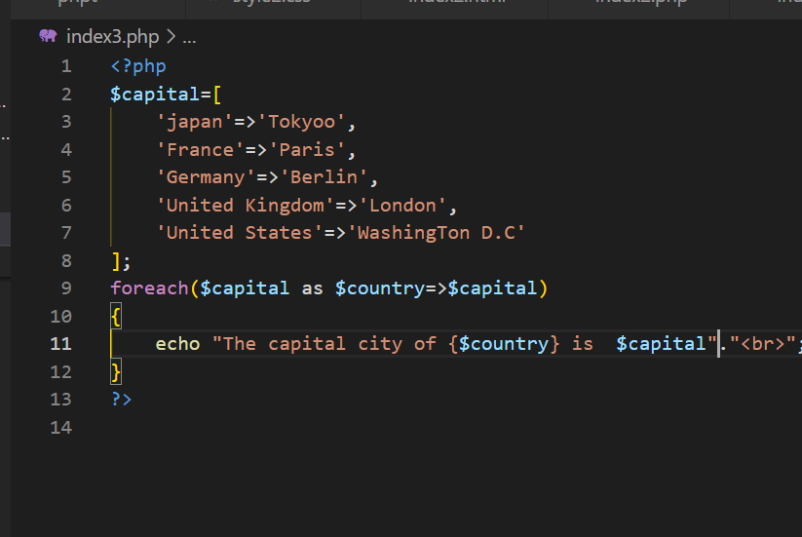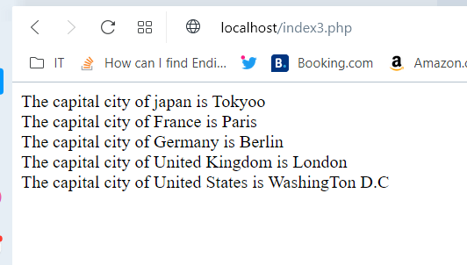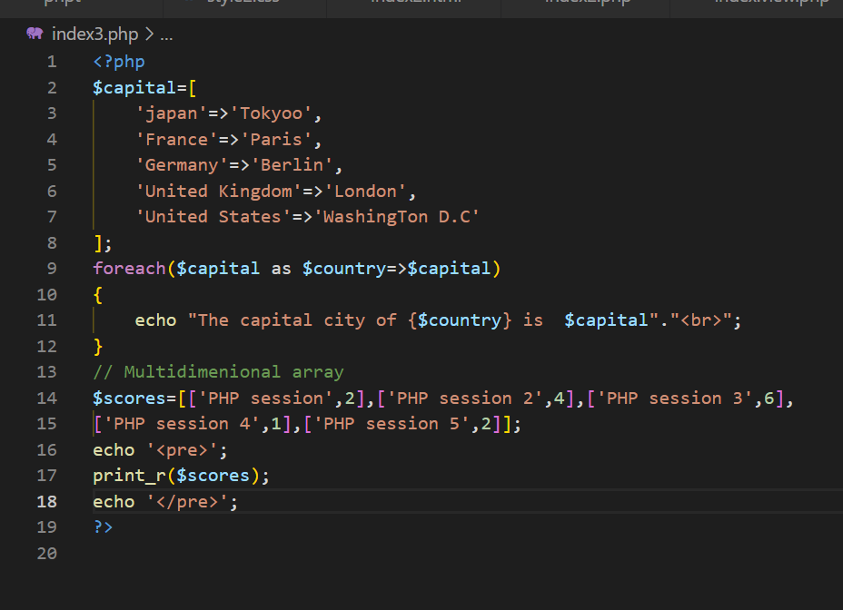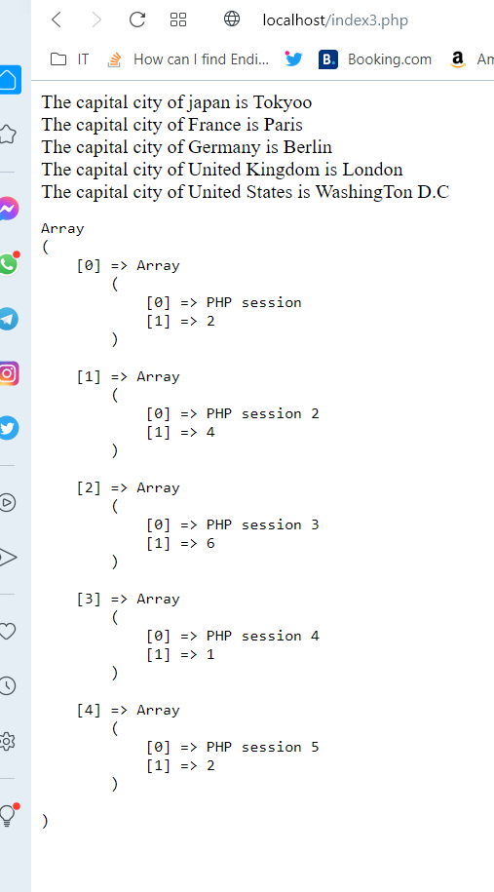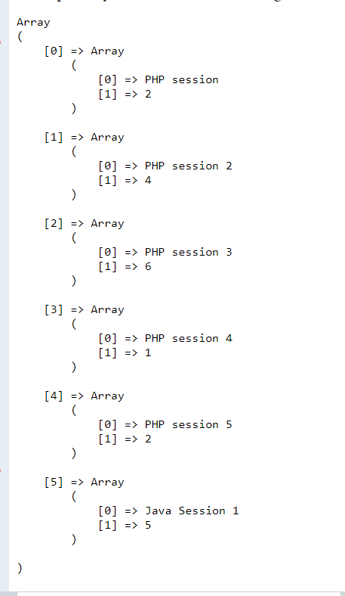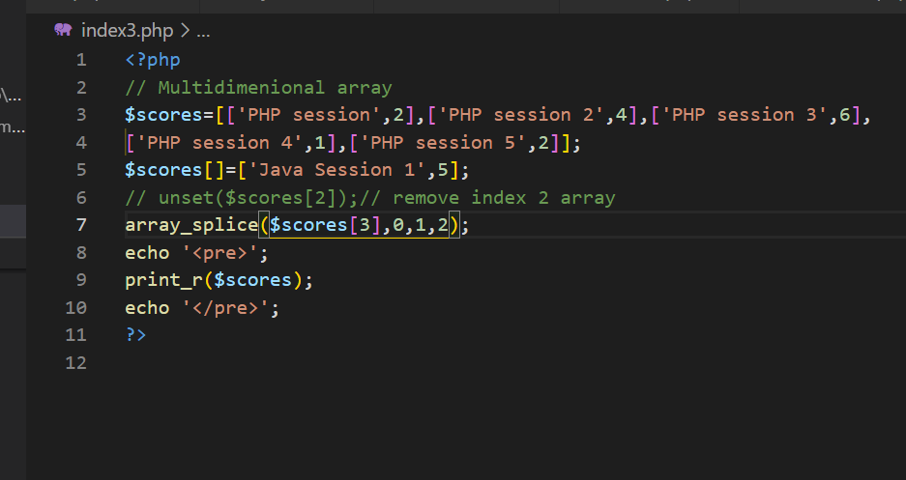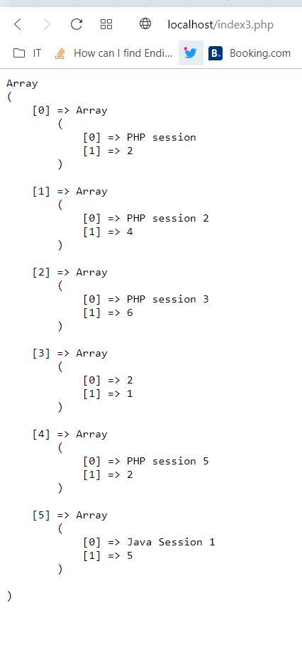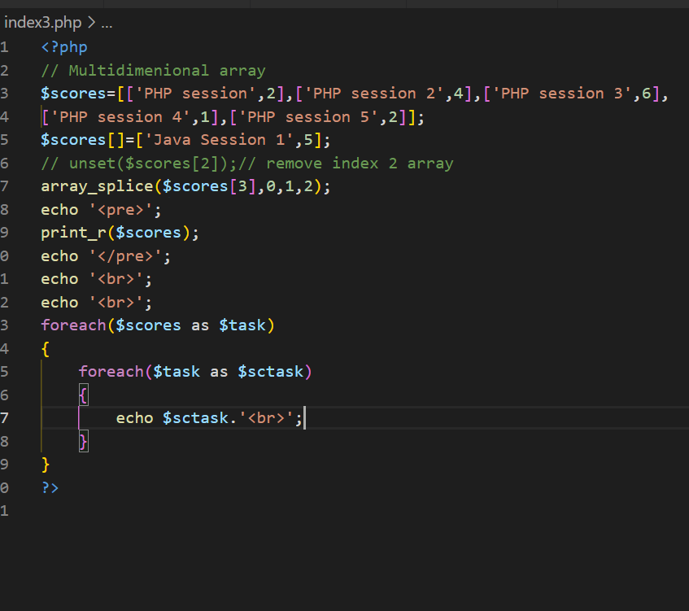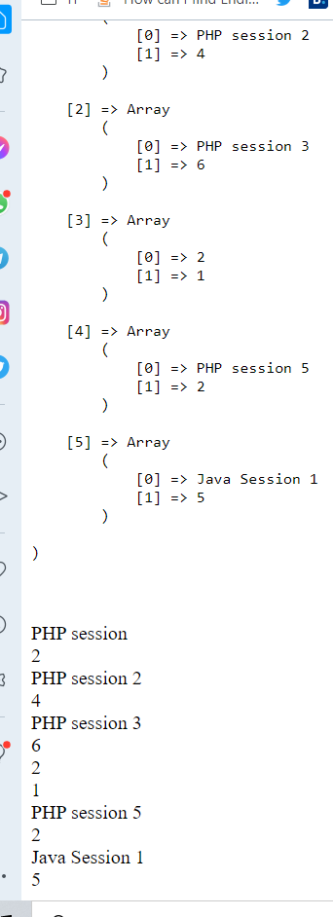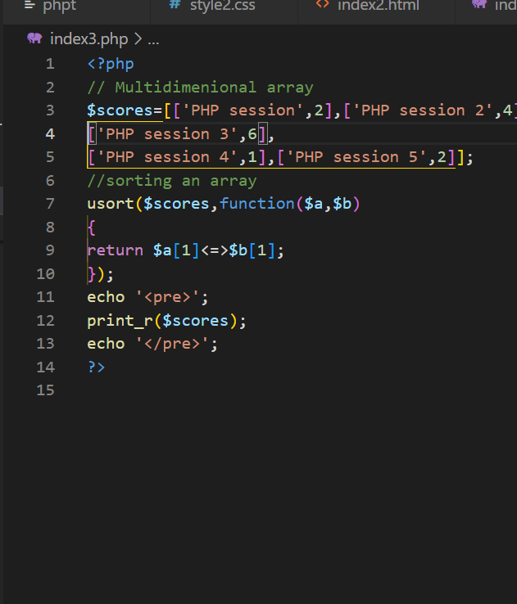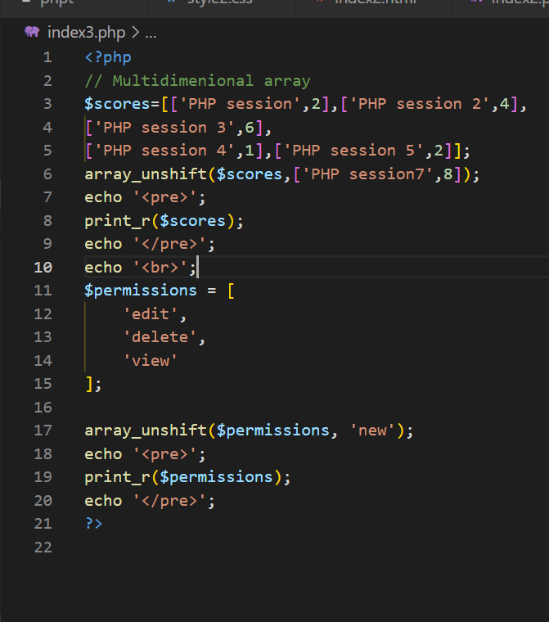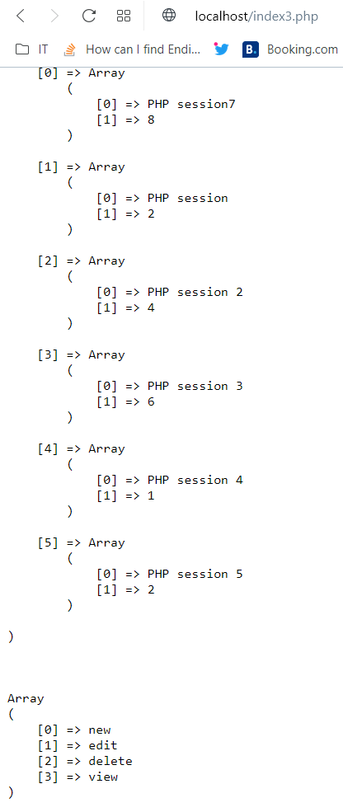

<?php

// Multidimenional array

$scores=[['PHP session',2],['PHP session 2',4],

['PHP session 3',6],

['PHP session 4',1],['PHP session 5',2]];

array_unshift($scores,['PHP session8',8],

['PHP session9',4],['PHP session10',5]);

echo '<pre>';

print_r($scores);

echo '</pre>';

echo '<br>';

$permissions = [

    'edit',

    'delete',

    'view'

];

// use of an array_unshift functions

array_unshift($permissions, 'cancel','approve'

,'valid','hide');

echo '<pre>';

print_r($permissions);

echo '</pre>';

?>

Output:

Array

(

[0] => Array

(

[0] => PHP session8

[1] => 8

)

[1] => Array

(

[0] => PHP session9

[1] => 4

)

[2] => Array

(

[0] => PHP session10

[1] => 5

)

[3] => Array

(

[0] => PHP session

[1] => 2

)

[4] => Array

(

[0] => PHP session 2

[1] => 4

)

[5] => Array

(

[0] => PHP session 3

[1] => 6

)

[6] => Array

(

[0] => PHP session 4

[1] => 1

)

[7] => Array

(

[0] => PHP session 5

[1] => 2

)

)

Array

(

[0] => cancel

[1] => approve

[2] => valid

[3] => hide

[4] => edit

[5] => delete

[6] => view

